Fig 1: Suspected cases tested by VRDLs for dengue and % positivity, 37th week of Sep, 2016
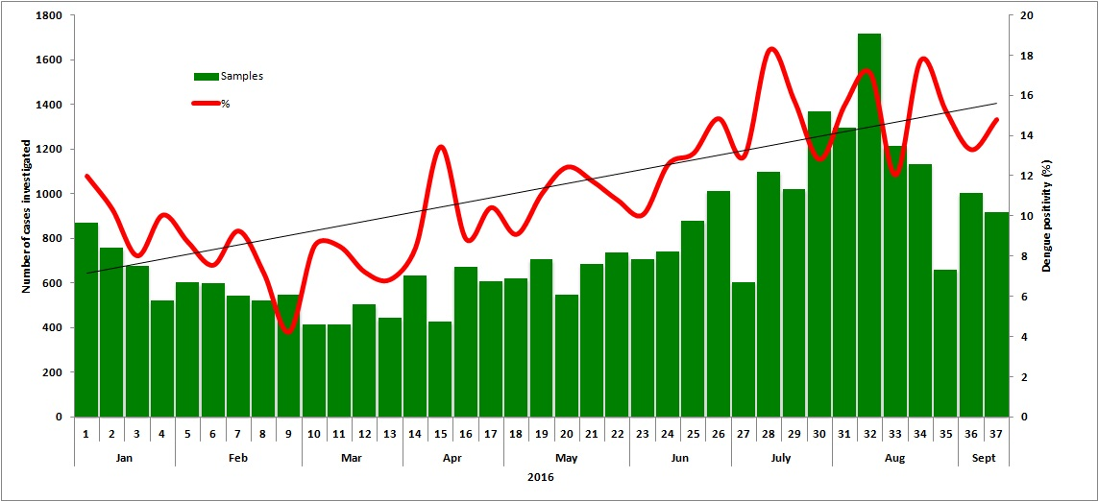

Fig 2: Suspected cases tested for Chikungunya and % positivity in 35 VRDLs, 37th week of Sep, 2016
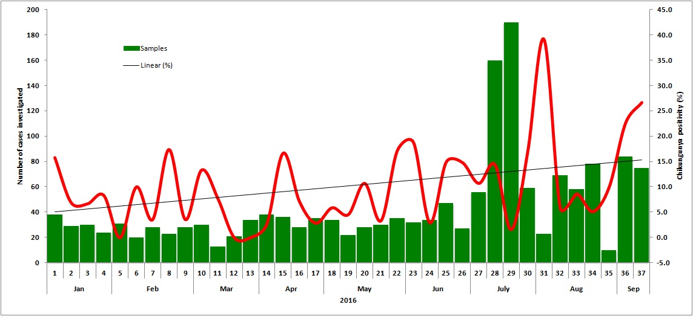

Table 1: Cumulative number of samples tested for dengue and Chikungunya, 37th week of Sep 2016
Name of the VRDL | Dengue |  | Chikungunya
 | Samples tested | No. positive (%) | Samples tested | No. positive (%)
KMC Manipal, Karnataka | 472 | 71 (15.0) | 11 | 0 (0)
RMRC, Port Blair, Andaman and Nicobar | 124 | 14 (11.3) | 7 | 2 (28.5)
Late SBKMGMC, Jagdalpur, Chattisgarh | 8 | 1 (12.5)
BJMC, Ahmadabad, Gujarat | 165 | 16 (9.7) | 5 | 0 (0)
NEIGRIHMS, Shillong, Meghalaya | 51 | 16 (31.4) | 51 | 18 (35.3)
GMC, Jamnagar, Gujarat | 67 | 15 (22.4) | 1 | 0 (0)
MMC, Madurai | 12 | 2 (16.7)
S.V. IMS, Tirupati | 11 | 0 (0)
GMC, Theni | 6 | 1 (16.7)
Total | 916 | 136 (14.8) | 75 | 20 (26.6)

