TECHNIQUE/EXPERTISE ACQUIRED

1. DATA / INFORMATION COLLECTED
1.1 INFORMATION

I had a discussion with MRI Technologist and Professors at the University of Cincinnati, Ohio. When a person comes for diagnosis, she/ he is examined initially by HDRS (Hamilton Rating Scale for Depression- Attached in ANNEXURE). HDRS is a multiple item questionnaire used to provide an indication of depression evaluation, while YMRS (Young Mania Rating Scale Measure- Attached in ANNEXURE) is for mania. It is a guide to evaluate the status of disease. The questionnaire is designed for adults and is used to rate the severity of their depression by the evaluations of probing mood, feelings of guilt, suicide ideation, insomnia, agitation or retardation, anxiety, weight loss, and somatic symptoms. Based on the rating, he/she is enrolling in a clinical trial. Normally the rating of 0–7 is generally accepted to be within the normal range (or in clinical remission), while a score of 20 or higher (indicating at least moderate severity) is usually required for entry into a clinical trial.
BPD patients acquire a structural MRI, fMRI and MRS study on three separate visits. During week-1 images are captured without medicine, after 1 week of meditation with either Seroquel or Lithium. At week-8, images are captured with medicine. All subjects were scanned on a 4 T Varian Unity INOVA whole-body MRI (Varian Inc., Palo Alto, CA). After that only the physicians knows the level of dosage of medicine prescribed to that patient.

Before capturing images, the radiologic technologist shims and tunes the system. It is used to adjust position and parallelity of the pole faces of an electromagnet.
Researchers focus on the following Brain Regions
- The anterior cingulate cortex (ACC), it is involved in rational cognitive functions, such as reward anticipation, decision-making, empathy, impulse control, and emotion.
- Ventrolateral prefrontal cortex (VLPFC), part of the prefrontal cortex, is located on the inferior frontal gyrus, is bounded superiorly by the inferior frontal sulcus and inferiorly by the lateral sulcus.
1.2 MR SPECTROSCOPY (MRS)
MR Spectroscopy (MRS) provides a measure of brain chemistry. The peak values of Glutomate specify the emotional regulation [24].
MRS Voxel positions:
Anterior Cingulate Cortex (Acc)- Left and right Ventrolateral Profontal Cortex( L, R- VLPFC)
Acquisition:
Single- Voxel- PRESS (Point Resolved Spectroscopy) spectra, Voxel Size 8 cc. repetition time 2000 ms, echo time 23 ms and 128 averages.
Positive co-relation between Acc Glu levels and fMRI BOLD signal within bipolar depression group was found significant during emotional and neutral cue.

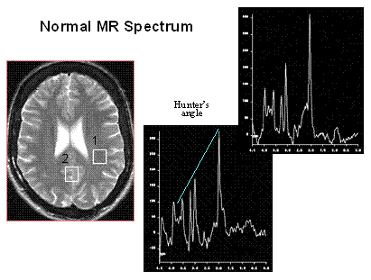
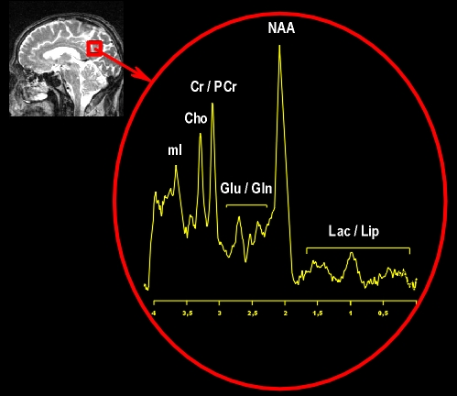
Figure 1 MRS for Healthy Control

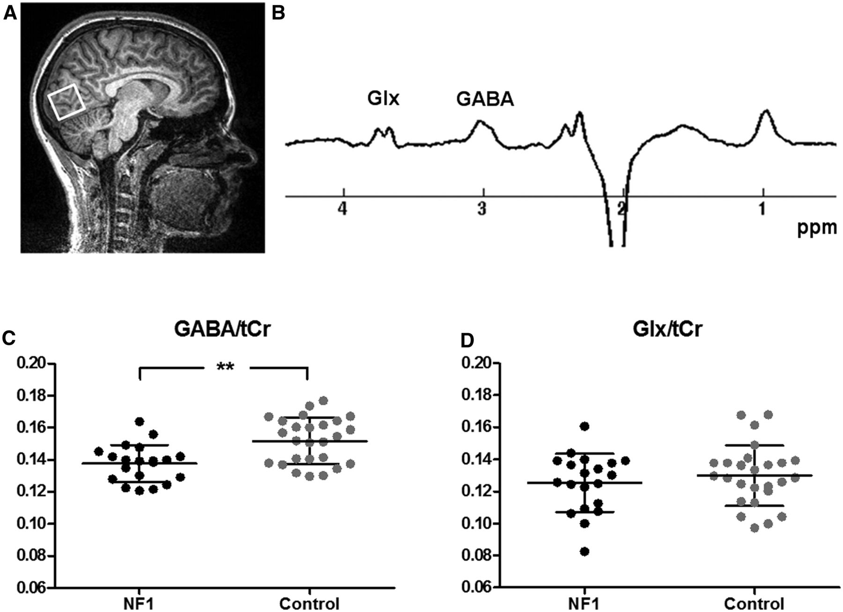
Figure 2 MRS for affected BPD patient
REMARKS
1. In Healthy Control, negative correlation between fMRI and Glu in the left- VLPFC may indicate that fMRI activation is more efficient at lower Glu levels, possibly representing lower neurotoxicity due to more efficient uptake and recycling of Glu by healthy glutamatergic synapses than what occurs in bipolar
2. Alternatively, the positive fMRI- Glu co-relation in the Acc of Bipolar depressive subjects suggests that regional Glu net turnover is abnormal and potentially responsible for fMRI changes in bipolar depression. MRS study has reported the Glu concentration in gray matter is much higher than in white matter. The abnormal Glu net turnover is likely due to reduced gray matter volume of subgenual ACC in the subjects with Bipolar Disorder
3. The astrocyte plays a key role in uptake and recycling of glutamate, a major excitatory neurotransmitter in Brain
1.3 fMRI IMAGE
BPD patients show abnormal brain activation to emotional cues on functional MRI. The present analysis examined association between fMRI activation and MRS of Glutamate (Glu).
During capturing f-MRI image, the MRI Technologist gives brain activity to the patient through some games. During activation stage of Brain, the researchers are finding the abnormalities in prefrontal and anterior cingulate cortices. Since, they are implicated in disturbances of attention, cognition, and impulse regulation in bipolar disorder. Acute episodes have been associated with dysfunction in these brain regions, and more enduring trait-related dysfunction has been implicated by volumetric and cellular abnormalities in these regions.
fMRI scan with Continuous Performance Task with Emotional and Neutral Distractors(CPT- END) and a resting state MRS scan on a l-Testa whole body MRI Scanner.
fMRI with CPT – END Tasks
two fMRI scans were acquired using T2 weighted gradient echo planar imaging pulse sequence ( repetition time/ echo time 300/29 msec, field of view 20.8 x 20.8 cm, motion 64 x 54 pixels, slice thickness 5mm, flip angle 75⁰.) while performing the CPT-END paradigm.
SOFTWARE:
AFNI (Analysis of functional Neuro image)
1.4 DATA SET COLLECTED
For Analysis purpose, collected 25 samples of BPD affected images and healthy controls in the below formats
1. Structural MRI
2. Diffusion tensor MRI
3. fMRI (activation)
4. MRS- neural metaboilite concentrations from Lithium
MRS- neural metaboilite concentrations from Seroquel
5. Clinical rating HDRS & YMRS
6. Treatment response
7. HDRS
Note: For Breast Cancer Choline is high in MR Spectrum
1.5 FOLLOW UP ACTIONS OF VISIT
1. Collected Data/ Information (25 samples- Healthy Control & BPD Patient)
2. Got training for the problem "Integrating Multi-Dimensional Data to
Explore the Biomarkers of Bipolar Disorder (BPD)” as my post-doctoral Study
3. We have proposed a new feature vector (3D SIFT) and implemented. the
Feasibility study is also experimented with earlier work. Planned to
publish the outcome in referred journal.
4. Have future collaboration with this work.

RESEARCH RESULTS, INCLUDING ANY PAPERS, PREPARED/SUBMITTED FOR PUBLICATION

1. FEATURE EXTRACTION
1.1 INTRODUCTION

We have extended the work done by Chen et. al.[27]. We introduced a new 3D SIFT features to detect brain structural changes from MRI images. We have experimented the feasibility of 3D SIFT features by means of SVM Classifier.
1.2 2D SIFT Features (EXISTING METHOD)

We used 2D implementation of the SIFT algorithm to extract features from the brain images. SIFT is widely used to identify salient features from images [22]. Fig. 1 shows an example of a brain slice with identified 2D SIFT features. A 2D SIFT feature is described by 132 numbers: 1 number for feature scale, 2 numbers for center location, 1 number for orientation and 128 numbers for appearance matrix, which characterizes the image appearance around the center of the feature.
In 2D SIFT, we have to process 2D plane and key points are obtained by selecting a small matrix in that particular slice. Using 2D SIFT, key points are extracted using 3 X 3 blocks (9 elements: the 4th element current point, process with 8 direction). Average key points generated are 32/frame for a single dataset. Time required for extracting key points is 663 seconds for single dataset.
The size of the regions is determined through experiments and it is set to 20 × 20 × 20 in this study. For brain images with the size of 192 × 256 × 156, there are 9 × 11 × 9 regions for every slicing orientation. Formulae applied for generating key points using 2D SIFT feature is given in equations (1) to (4)
2 D magnitude gradient:
$m2d(x,y)=\sqrt{L_{x}^{2}+L_{y}^{2}}$ (1)
$L_{x}=L\left(x+1,y\right)-L\left(x-1,y\right)$ (2)
$L_{y}=L\left(x,y+1\right)-L\left(x,y-1\right)$ (3)
Orientation θ:
$θ(x,y)=\tan^{-1}{\frac{L_{x}}{L_{y}}}$ ( 4)
Applying 2D SIFT feature to query image, the average key points generated per frame is 32.06. The total key point generated for the entire slices is 6260. The key point generated for slices 100, 120 and 150 are shown as Figure 3, Figure 4 and Figure 5, respectively.

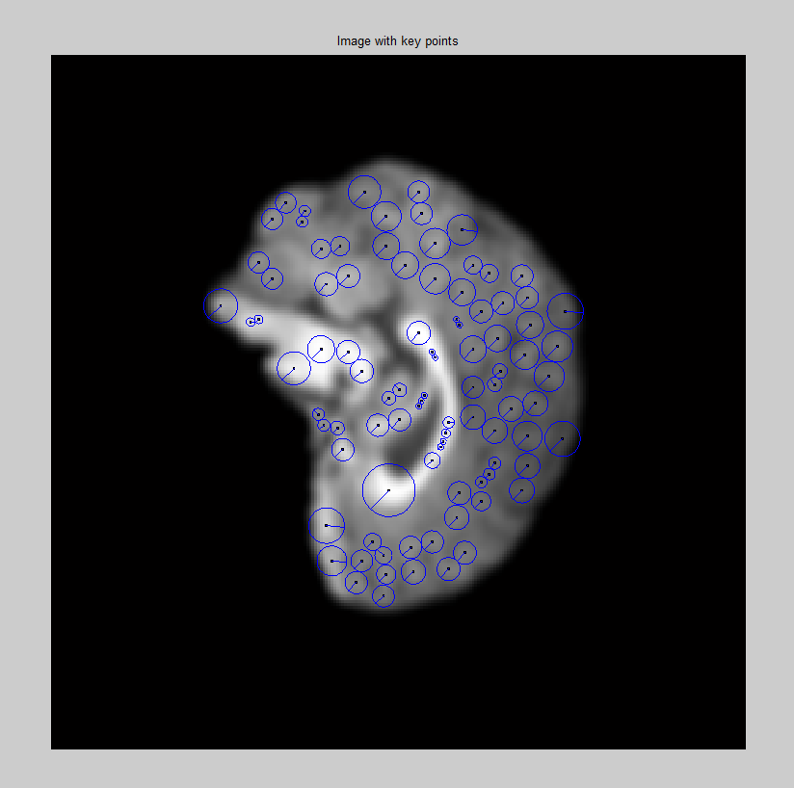
FIGURE 3 Key points generated for Slice 100 using 2D SIFT

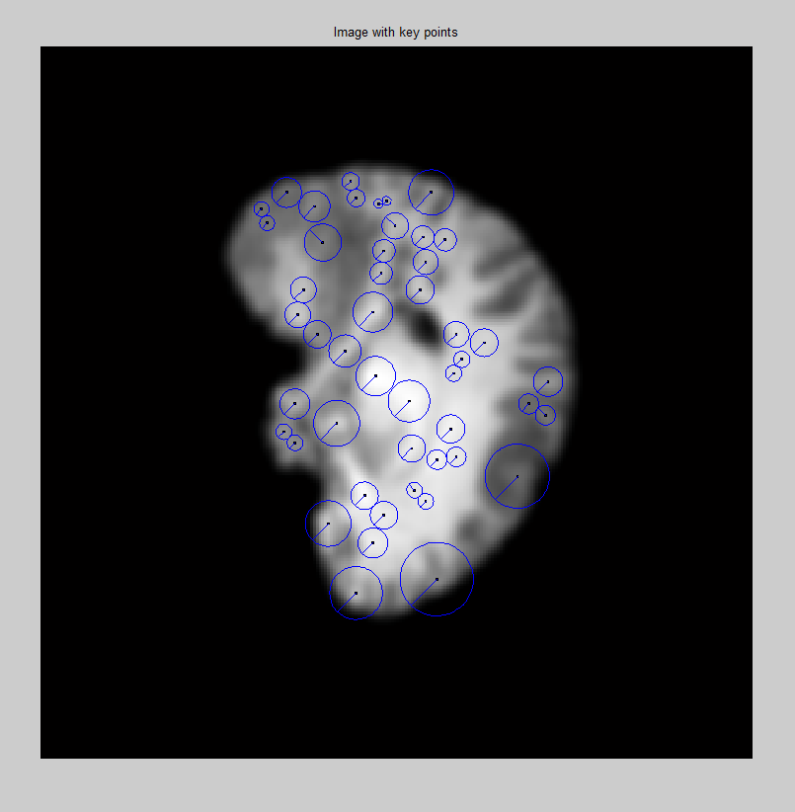
FIGURE 4 Key points generated for slice 120 using 2D SIFT

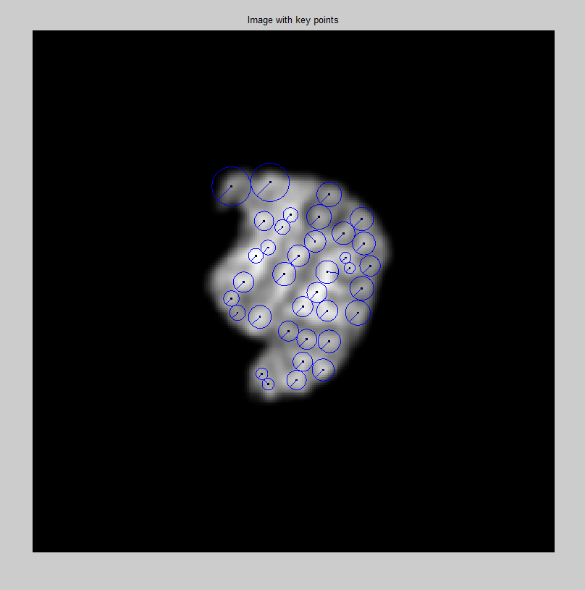
FIGURE 5 Key points generated for slice 150 using 2D SIFT

1.3 3D SIFT Features (PROPOSED METHOD)

Figure 4 specified the key point selection in 3D SIFT. In the 3D SIFT feature extraction, key points are obtained from the image using minimum 3 X 3 X 3 blocks (27 elements: the 14th element current point, process with 26 directions). The average key point for a single dataset is 3 per frame. Time required extracting key point is1221 seconds for a single dataset.

In 3D SIFT, the processing is x, y and z plane, i.e. cubical structure. If we process 5th slice, key points are generated by combining 4th and 6th slices

Z
. (x,y) Y

X

Figure 6 Pictorial representation of 3D Key point generation

The size of the image selected is (X, Y, Z), current position is (x,y) . Formulae applied for generating key points using 3D SIFT feature is given in equations (5) to (12)
3D magnitude gradient:
$m3d(x,y,z)=\sqrt{L_{x}^{2}+L_{y}^{2}+L_{z}^{2}}$ (5)
$L_{x}=L\left(x+1,y,z\right)-L\left(x-1,y,z\right)$ (6)
$L_{y}=L\left(x,y+1,z\right)-L\left(x,y-1,z\right)$ (7)
$L_{y}=L\left(x,y,z+1\right)-L\left(x,y,z-1\right)$ ( 8)

Orientation
$θ(x,y,z)= tan-1(Ly/Lx)$ ( 9)
$∅\left(x,y,z\right)=\tan^{-1}\left(\frac{L_{z}}{\sqrt{L_{x}^{2}+L_{y}^{2}}}\right)$ (10)
Find Soild Angle ( ω)
$ω=∆∅(\cos{θ}-\cos\left(θ+∆θ\right)$ (11)
$hist\left(i_{θ},i_{∅}\right)+=\frac{1}{ω}m3D(x^{'},y^{'},z^{'})e^{\frac{-({\left(x-x^{'}\right)}^{2}+{\left(y-y^{'}\right)}^{2}+{\left(z-z^{'}\right)}^{2})}{2σ^{2}}}$ (12)
- Constant

Using 3D SIFT, total key points generated is 436. A 3D SIFT feature is described by 133 numbers: 1 number for feature scale, 3 numbers for center location, 1 number for orientation and 128 numbers for appearance matrix, which characterizes the image appearance around the center of the feature.
The key point generated for slices 100, 120 and 150 are shown as Figure 7, Figure 8 and Figure 9. Considering slice number 100, key points are generated. Here Red color shows the presence of key points generated in 99th slice and Blue color shows the presence of key point in 100th slice and cyan color shows the presence of key point in 101th frame.

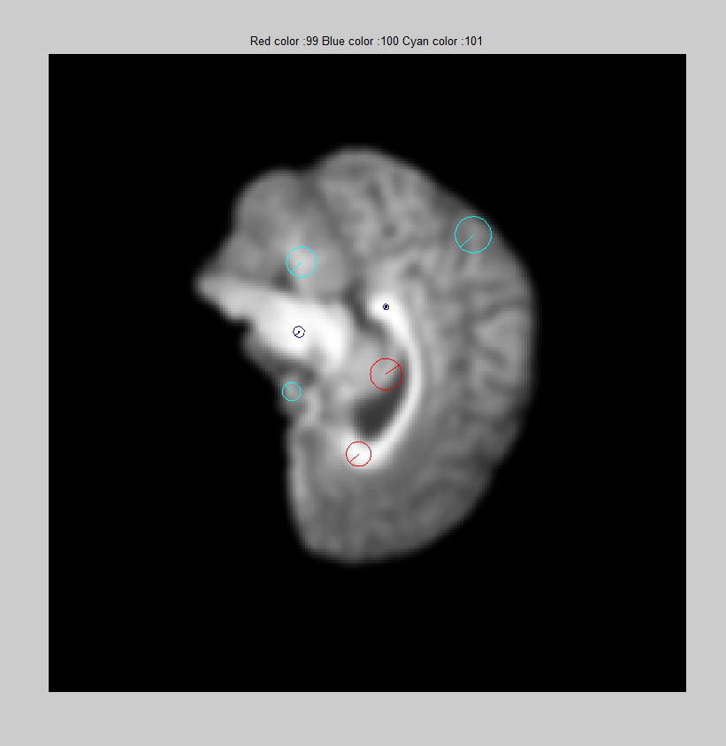
Figure 7 Key point generated for slice 100 using 3D SIFT
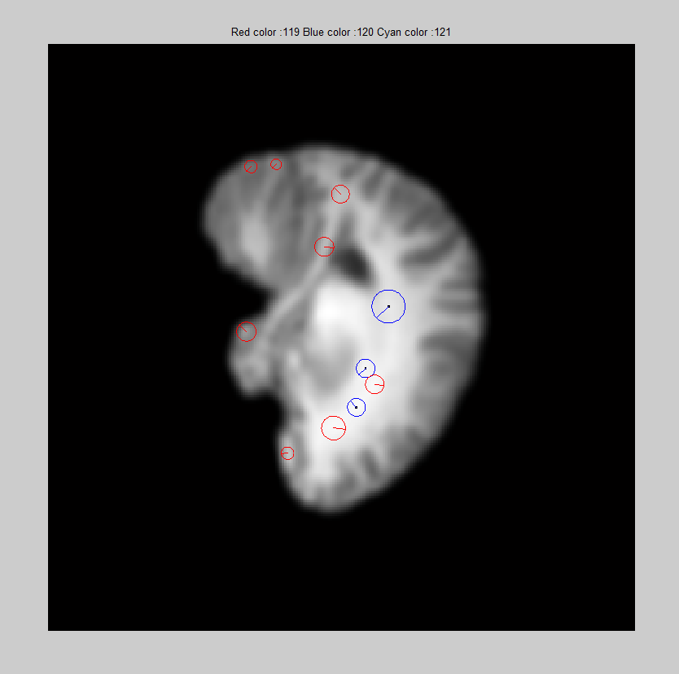
Figure 8 Key point generated for slice 120 using 3D SIFT

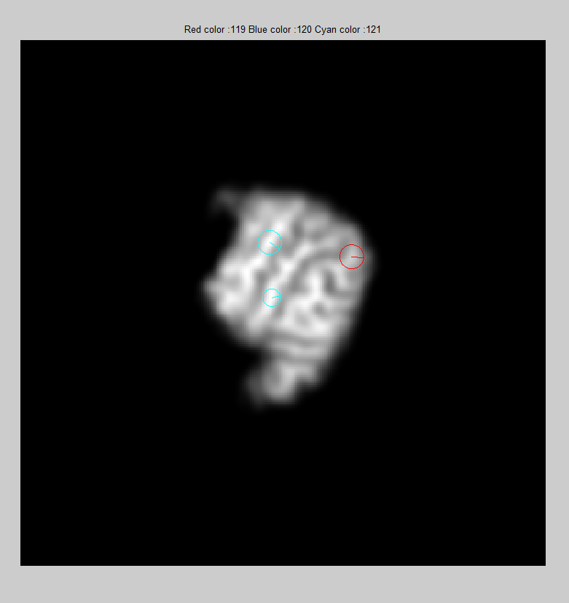
Figure 9 Key point generated for slice 150 using 3D SIFT

1.4 CONCLUSION

This chapter explained in detail about key point generation using 2D SIFT & 3D SIFT feature extraction technique. Figures showed the output results for key point generated. The rationale behind this proposed work is the number of key point generated is very less when compared with earlier method. The proposed feature has been computed and is used for subsequent experimentation with identifying biomarkers for BPD.

2. CLASSIFICATION

2.1 INTRODUCTION

Brief explanation of the proposed feature has been presented in the previous chapter. Classification refers to assigning a physical object or incident into one of a set of predefined categories. In texture classification, the goal is to assign an unknown sample image to one of a set of known texture classes. Classification is based on a discrimination function using several texture characteristics. Supervised classification, which is based on discrimination function using several image features. This method requires prior information about the images to be classified.

2.2 SUPERVISED CLASSIFICATION

Classification process involves two phases: the learning phase and the recognition phase. In the learning phase, the objective is to build a model for the representation of each class present in the training data. The content of the training images is captured with the chosen analysis method, which yields a set of features for each image. In the recognition phase, the content of the unknown sample is first described with the same analysis method. The feature has been evaluated from the point of view of discrimination performance. The simple discrimination method was used, and the number of mathematical operations involved was small.

The steps involved in training and classification is shown in Figures 10 and 11. In training, feature for the known images using the formulae given in equations 5 to 12 are obtained and stored in features library. Using this procedure, the features of known images are computed and stored in the features library, which are further used in texture classification.

SIFT Preprocessing
Feature

Extraction
( key point generation)

Features

Library

Known
Brain Image

Figure 10 Training Stage
SIFT Preprocessing
Feature
Extraction
( Key point Generation)

Classifier
Features
Library
Unknown
Brain Image
Diagnosis

Figure 11. Supervised Classification Stage

The entire procedure for the classification is presented in the form of an algorithm below.

Algorithm

SVM CLASSIFIER

Input : Brain Image (256 Slices)
Feature Extraction: Key Points Generation
Query Image: Image (256 slices)
Input for Classifier: Key points to the particular Query Image
Output : The Tool will tell whether the Input is Normal or affected by BPD

In classification tasks, the features that characterize the samples have different ranges. First the features were normalized so that their values fall within a specified range. Neural network has drawn considerable attention in this area due to their solid theoretical foundation and excellent practical performance [23]. In this work, SVM classifier is used for training. The retrieval of the reasoning system Eammi et al. [23] uses the predict value of trained model. Given a training set of case instance label pair (x_{i},y_{i}), i=1,. . . l where and ,the Support Vector Machines(SVM) (Boser et al., 1992; Cortes and Vapnik, 1995) [25][26] require the solution of the following optimization problem:
subject to ,
(13)
The training vectors, x_{i}, are mapped into a higher dimensional space by the function. SVM finds the linear separating hyperplane with the maximal margin in this higher dimensional space. is the penalty parameter of the error term. The sigmoid kernel function is used. For similarity measure, we have used the Euclidean distance.
3. RESULT ANALYSIS

3.1 INTRODUCTION

An elaborate literature review has been presented in Chapter 1. In this module, the results obtained in 2D SIFT & 3D SIFT are discussed.

3.2 EXPERIMENTAL RESULTS AND DISCUSSIONS
This work introduced a novel local feature extraction technique, 3D- SIFT. The feasibility of the proposed feature is analysed with support vector machine (SVM) classifier. The whole process includes two steps, i.e., the image preprocessing, feature extraction and the classification of local image features based on SVM.
We analysed the retrieval process using the extracted feature. The key concept of this method is to use 3D SIFT feature alone as the feature measure of the image. Results are compared with Ye Chen et.al [27]. Our algorithm also has the advantage to have an extremely low computational cost. It thus has the potential to be a powerful tool for automating the discovery of meaningful categories in large data sets.

The performance of proposed 3D SIFT feature is assessed by comparing the receiver operating characteristic (ROC) and two numerical measures of the ROC curves i.e. 1-specificity and sensitivity. ROC curve describes how the true positive rate and false positive rate change as the threshold of the classifier changes.
The formulae for calculating 1-specificity and sensitivity is given in Table 1

Table 1 Formula for Performance Analysis Measures
Sl.No | Performance measure | Formula
1 | Sensitivity
2 | Specificity
3 | Accuracy
where
True positive (TP) = correctly identified
False positive (FP) = incorrectly identified
True negative (TN) = correctly rejected
False negative (FN) = incorrectly rejected
P= TP+FP
N=FN+TN
By this consideration all the classes are tested and the values of true positive (TP), false positive (FP), true negative (TP) and false negative (FN) are derived. Then the statistical measures sensitivity, specificity and accuracy are calculated. The statistical report for the proposed work is given in Table 2.
For example, consider that the test set contains 26 datasets. For test retrieval, 10 datasets are TP, 1 as FN, FP as 3 and TN as 12. So the measures sensitivity = 90.91%, specificity = 80.0% and accuracy as 84.61%
Table 1. Statistical Report for proposed work
case | 3D SIFT ( Proposed Work) |  |  |  | 2D SIFT( work[27])
 | Accuracy | Sensitivity | Specificity | precision | Accuracy | Sensitivity | Specificity | precision
1 (16 Testing) | 81.25% | 85.71% | 77.78% | 75% | 75% | 75% | 75% | 75%
2 (16 Testing) | 81.25% | 77.78% | 85.71% | 87.5% | 68.75% | 71.43% | 66.67% | 62.5%
3 (16 Testing) | 87.5% | 87.5% | 87.5% | 87.5% | 81.25% | 85.71% | 77.78% | 75%
4 (14 Testing) | 85.71% | 100.00% | 77.78% | 71.42% | 78.57% | 83.33% | 75% | 71.42%
5 (12 Testing) | 83.33% | 83.33% | 83.33% | 83.33% | 75% | 71.43% | 80% | 83.33%
6 (26 Testing) | 84.61% | 90.91% | 80.00% | 76.92% | 73.07% | 80% | 68.75% | 61.53%

If we give a Query Image, the total time taken to extract features in a dataset and the time taken to perform retrieval process is given in Table 3.
Table 2 Comparison of Retrieval Time

S. No. | Approches | Total Feature point detection Time | Total Retrieval time
1 | 3D SIFT  (proposed work) | 663 sec/dataset | 0.175977 seconds.
2 | 2D SIFT  (work [27] ) | 1221 sec /dataset | 0.171611 seconds.

Using Matlab, we have implemented our proposed methodology and the earlier work [27] and tested with our native dataset. Graph 1 show the sensitivity/specificity obtained using proposed work and earlier work [27] and the result is given in Graph 1.

Graph 1 ROC Curve

